Program 5: Introduction to Jenkins: What is Jenkins?, Installing Jenkins on Local or Cloud Environment, Configuring Jenkins for First Use
Jenkins is an open-source automation server used to automate tasks in software development, especially Continuous Integration (CI) and Continuous Deployment (CD).
Why Jenkins is used
Jenkins helps developers automate repetitive tasks such as:
- Building code (compile programs)
- Running tests automatically
- Integrating code from multiple developers
- Deploying applications to servers
WAR File
Meaning
WAR = Web Application Archive
A WAR file is a compressed file used to deploy Java web applications.
It is similar to a ZIP file, but specifically designed for Java web applications.
What a WAR file contains
A WAR file typically includes:
- Java class files
- JSP files
- HTML pages
- CSS and JavaScript
- Libraries (.jar files)
- Configuration files (web.xml)
Structure of a WAR file
Jenkins WAR File
When you download jenkins.war, it already contains the complete Jenkins application.
You can run it directly using Java:
java -jar jenkins.war
Java will:
- Extract the WAR file
- Start an internal Jetty web server
- Launch Jenkins in the browser
Example access:
http://localhost:8080
or
http://localhost:9090

**Important**
Jenkins runs only on JDK 17, 21, or newer versions like 25 because these are Long Term Support (LTS) versions of Java that provide stability, security updates, and long-term compatibility.
- Long Term Support (LTS) Versions: Java versions such as JDK 17 and JDK 21 are LTS releases. These versions receive long-term updates and support from Oracle and the Java community. Jenkins relies on these stable versions to ensure reliable performance.
- Security and Stability: Older Java versions like JDK 8 or JDK 11 are gradually being phased out for newer Jenkins versions. Running Jenkins on supported LTS versions ensures better security patches and fewer compatibility issues.
- Compatibility with Modern Libraries: Jenkins uses many plugins and modern Java libraries that require newer Java features available only in JDK 17 or later.
- Future Support: Newer versions such as JDK 25 include improved performance, better memory management, and new language features, making Jenkins more efficient.

Execution Procedure
Step1: Go to the browser and type download jenkins
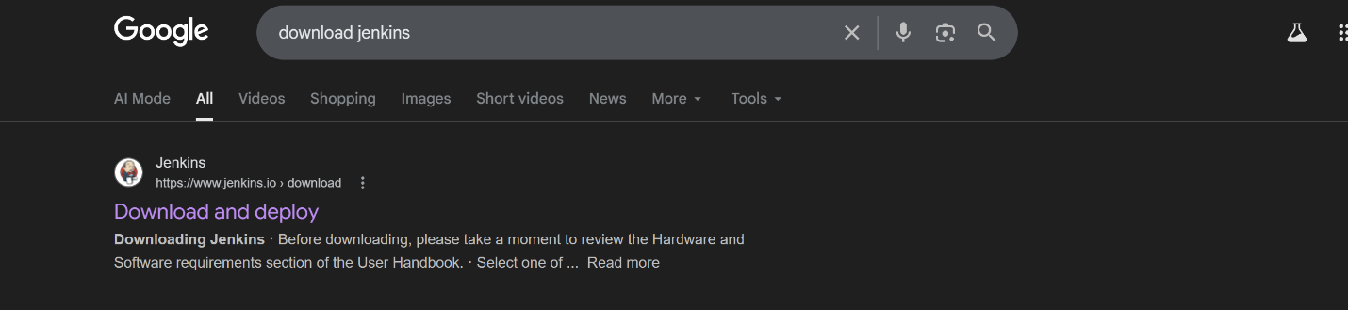

Step 2: Download Generic java package(.war)
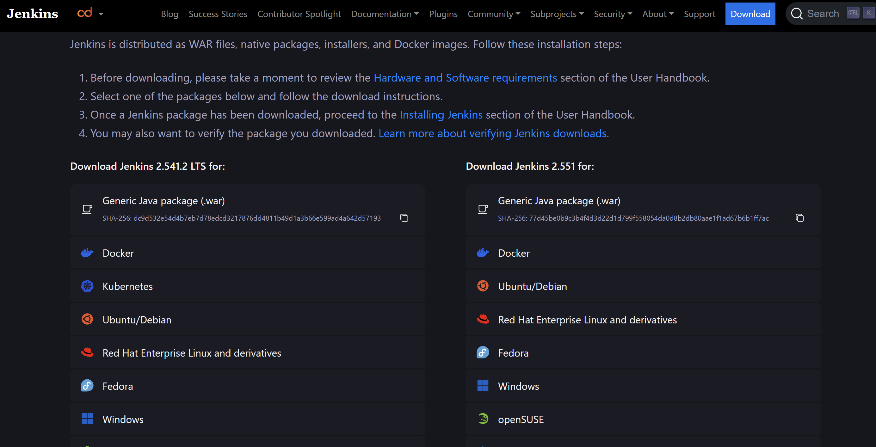w

Step 3: Navigate to the D drive and create a new folder named Jenkins. After downloading the .war file from the browser, copy the downloaded file and paste it into the D:\Jenkins folder.

Step 4: Open the Command Prompt and navigate to the Jenkins folder in the D drive where the jenkins.war file is stored. This can be done by using the following commands:
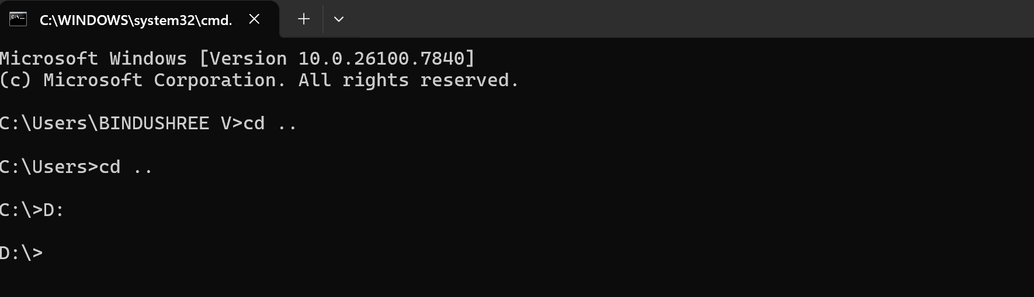

Step 5: In the Command Prompt, type the following command to run Jenkins: java -jar jenkins.war
By default, Jenkins runs on port 8080. If port 8080 is already in use, run Jenkins using another port (for example 9090) with the following command: java -jar jenkins.war --httpPort=9090. This command starts the Jenkins server, which can then be accessed through a web browser.
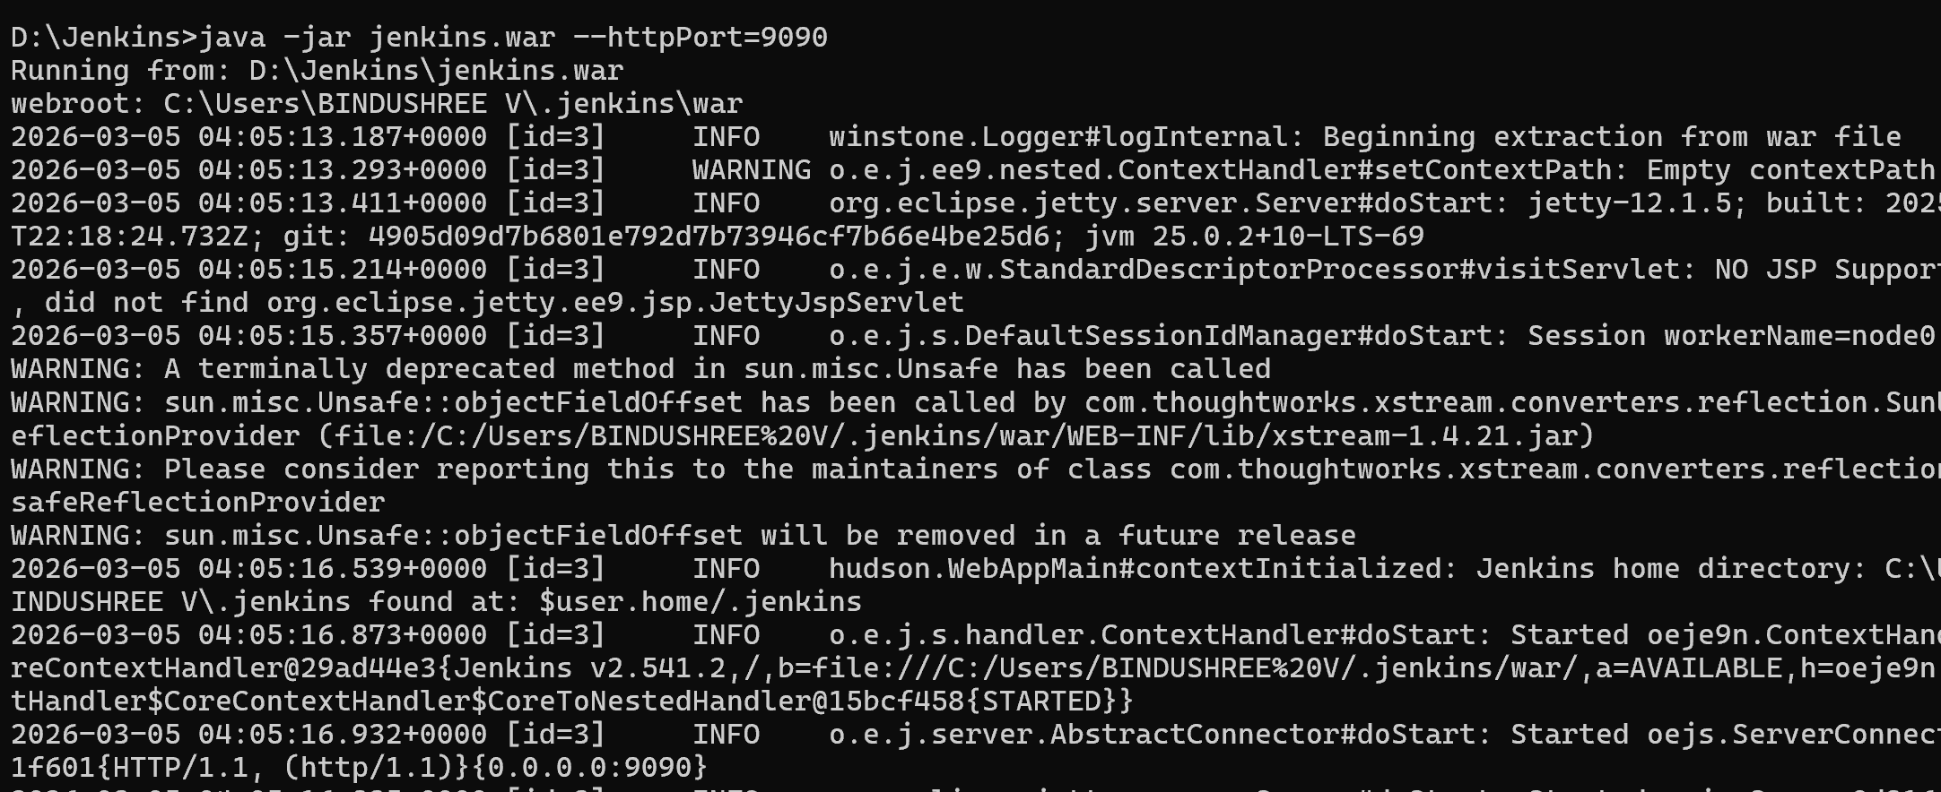

Step 6:
After Jenkins starts successfully, open a web browser and type the following address in the address bar:
- If Jenkins is running on the default port: http://localhost:8080
- If Jenkins is running on port 9090: http://localhost:9090
- After entering the address, the Jenkins Unlock page will appear in the browser, prompting the user to enter the initial administrator password to continue the setup process.
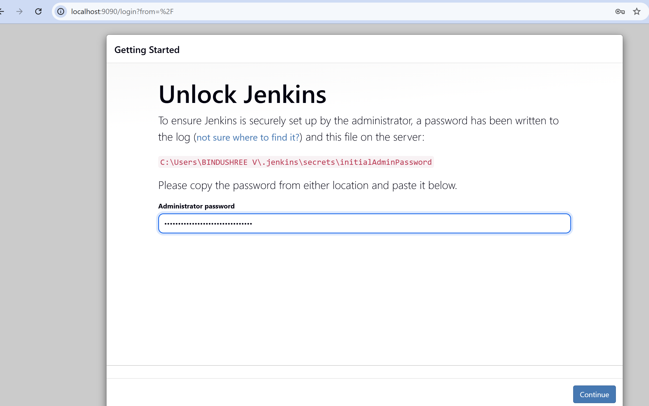
Step 6: After unlocking Jenkins, the system prompts the user to create the first administrator account.
The following details must be entered:
- Username
- Password
- Confirm Password
- Full Name
- Email Address
This account will be used to manage Jenkins and configure build jobs.
Note:
Make sure to remember the username and password created during the setup process, as they will be required for future logins to Jenkins. If these credentials are forgotten, you may not be able to access the Jenkins dashboard without resetting the configuration.

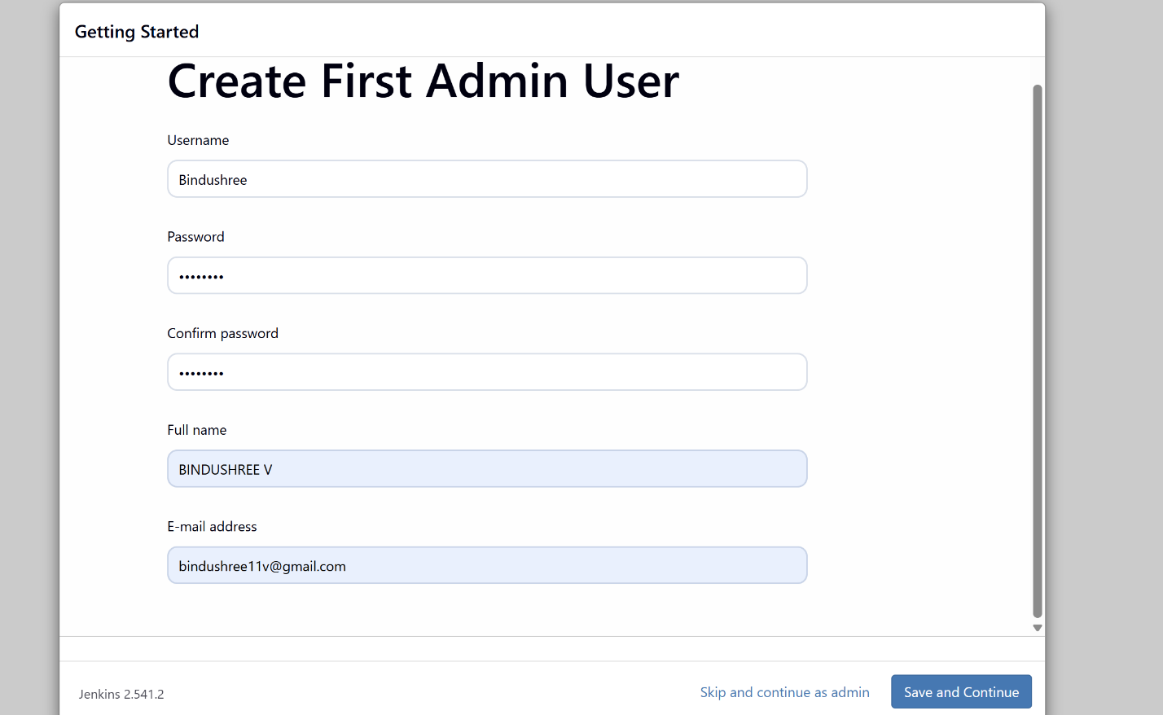

Step 7: Jenkins then asks the user to install plugins.
Two options are available:
- Install Suggested Plugins – installs commonly used plugins automatically.
- Select Plugins to Install – allows manual selection of plugins.
For beginners, it is recommended to select Install Suggested Plugins.
Plugins extend Jenkins functionality for tasks like Git integration, pipeline automation, build tools, and notifications.
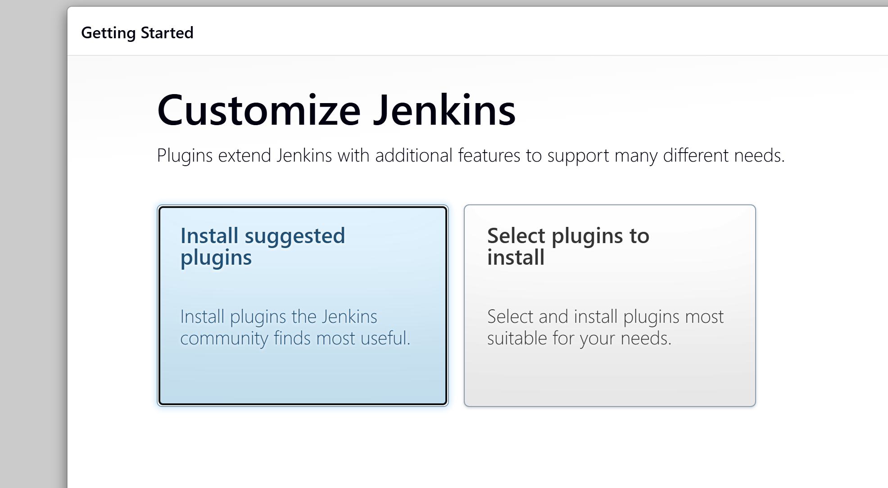

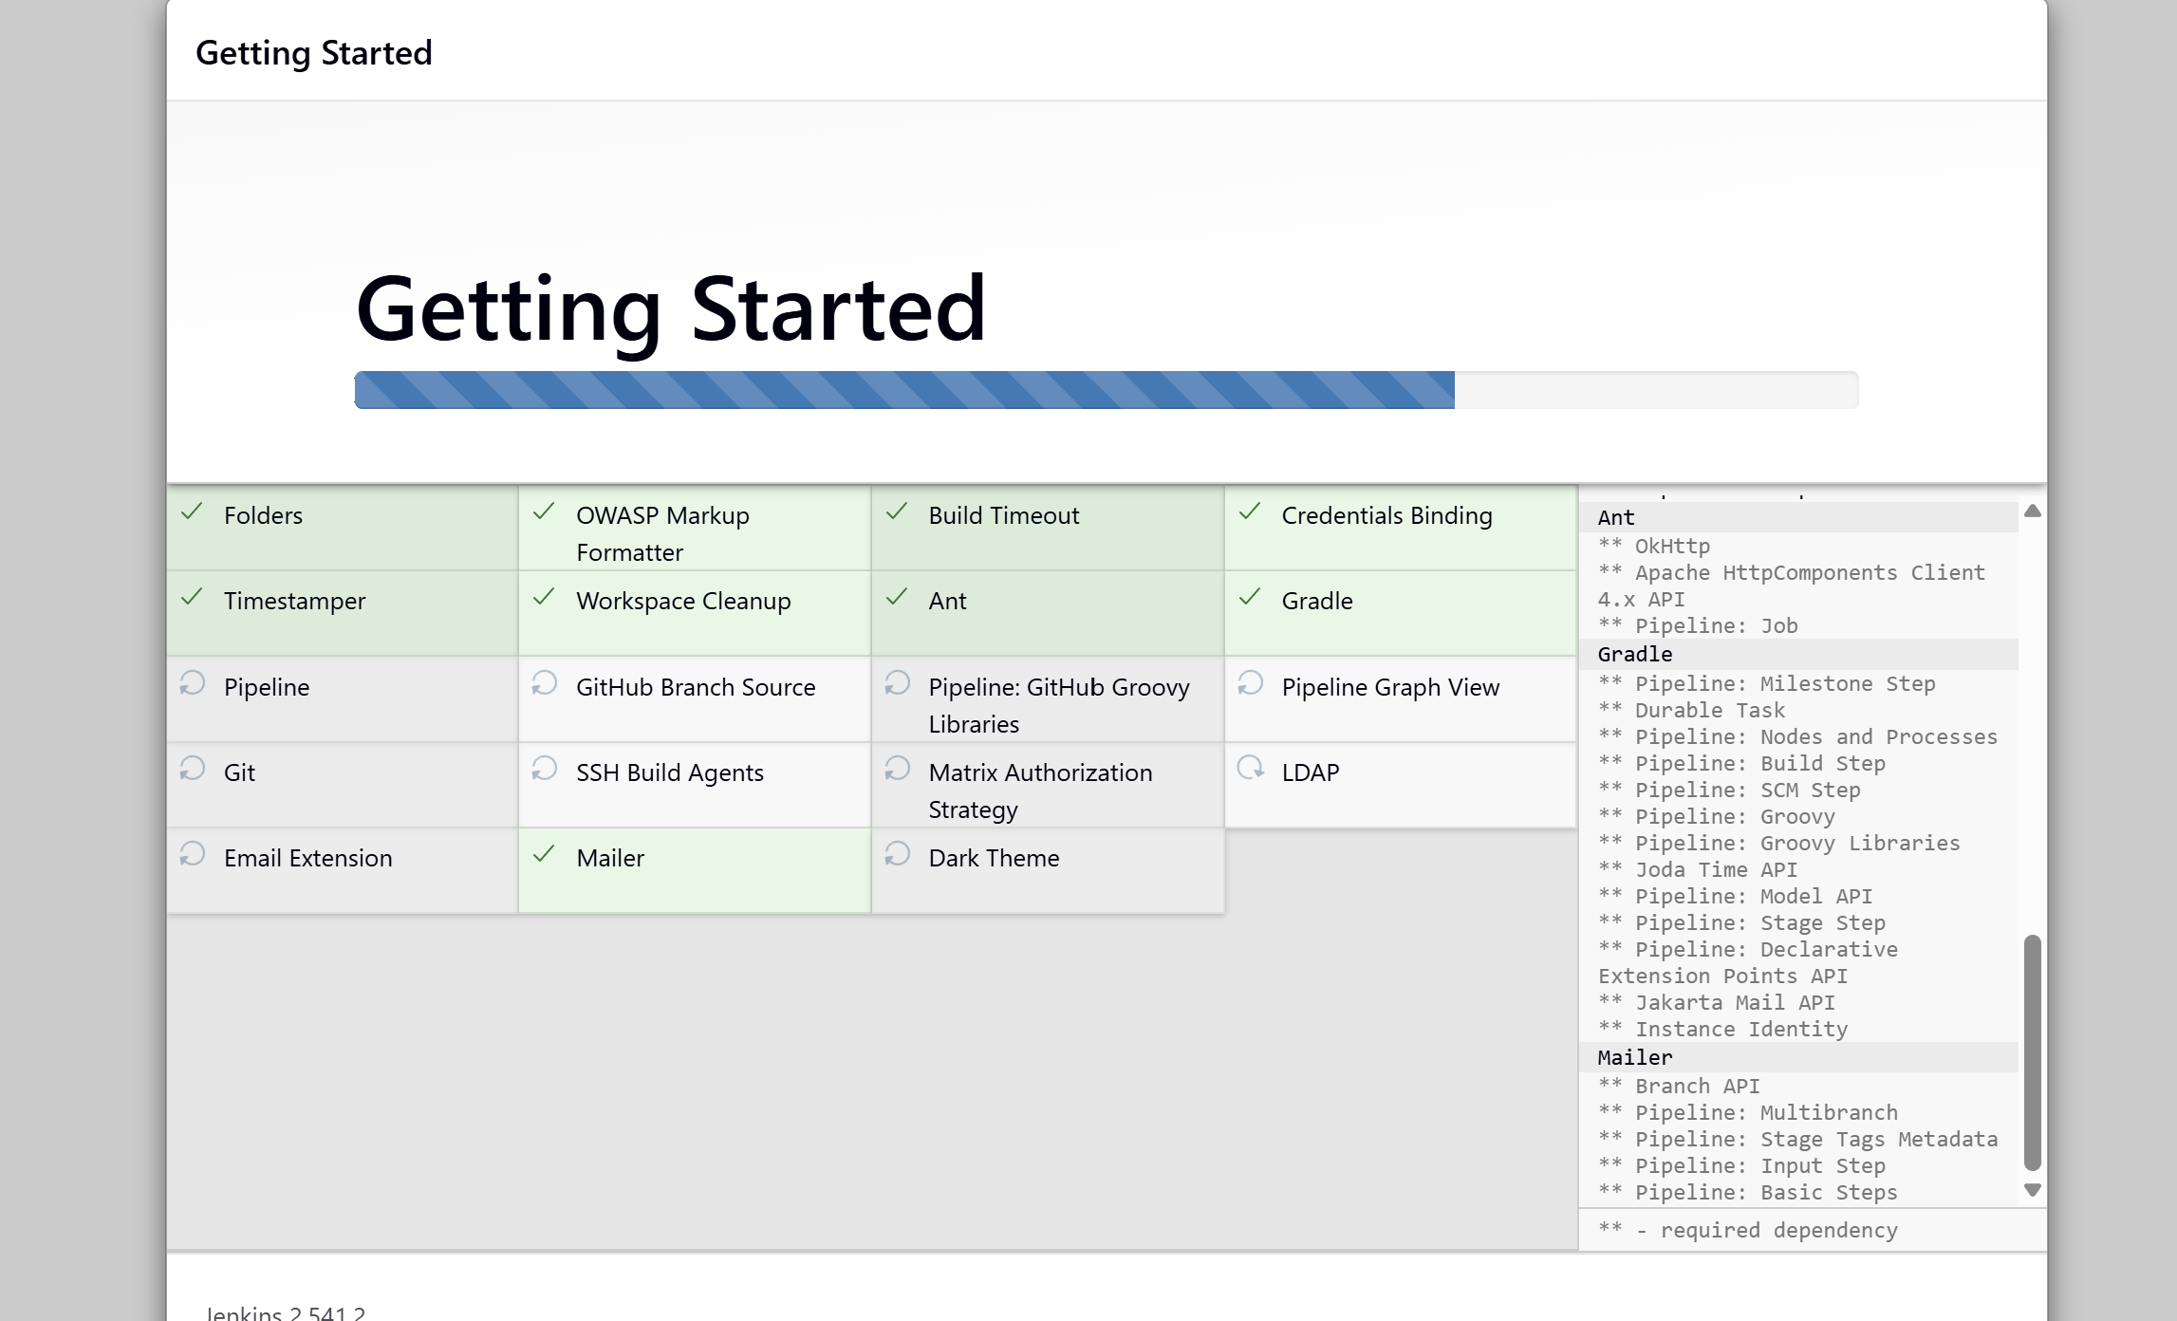

Once setup is complete, the Jenkins dashboard appears.
This is the main interface where users can:
- Create new jobs
- Monitor build history
- Configure pipelines
- Manage agents and cloud configurations
From here, users can start building and automating software projects.
